Mongo DB

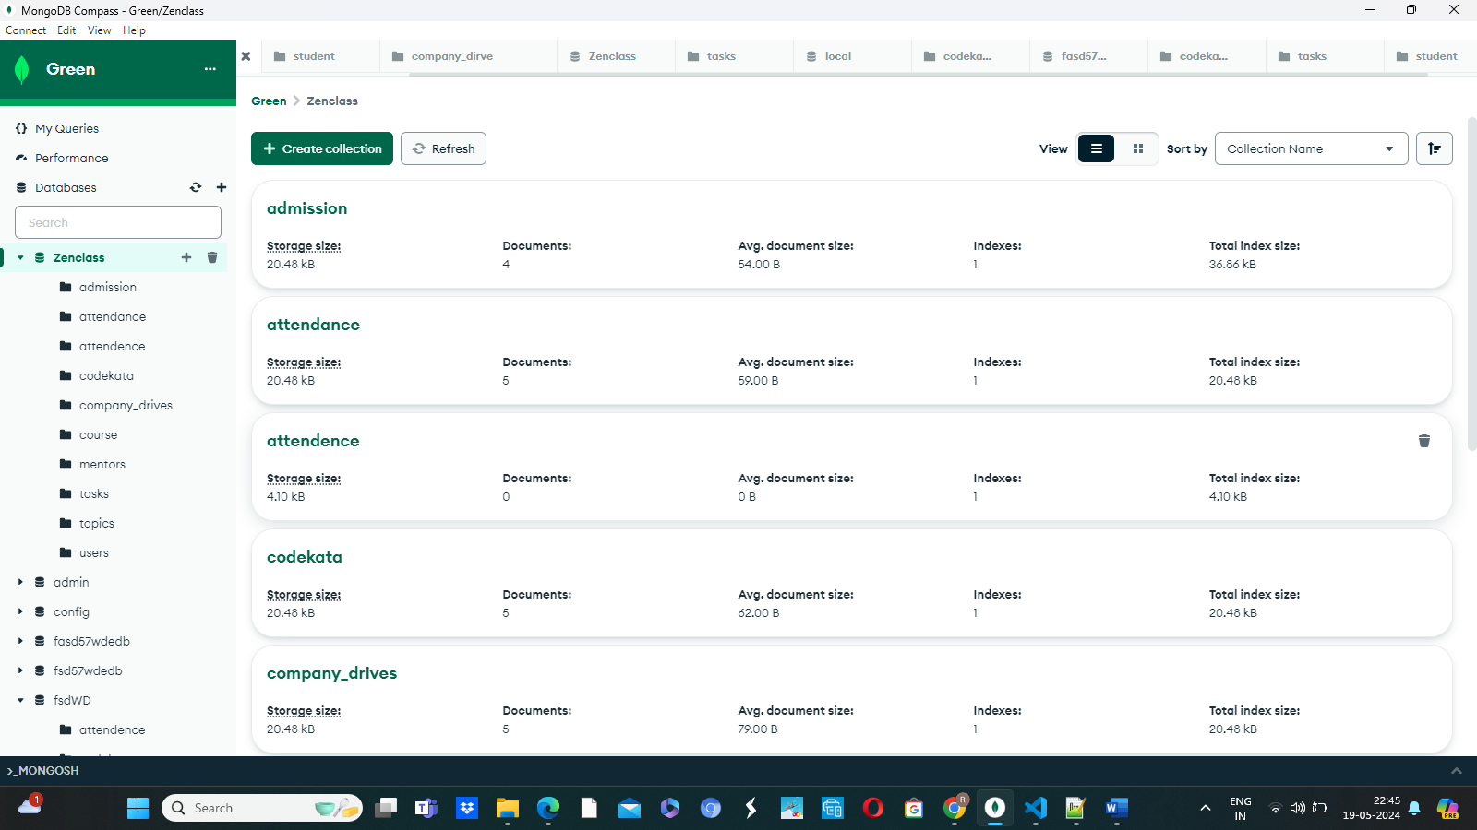

Use Zenclass;

Db.createCollection(adminssion);

Db.createCollection(users);

Db.createCollection(tasks);

Db.createCollection(topics);

Db.createCollection(companyDrive);

Db.createCollection(attendence);

Db.createCollection(codekata);

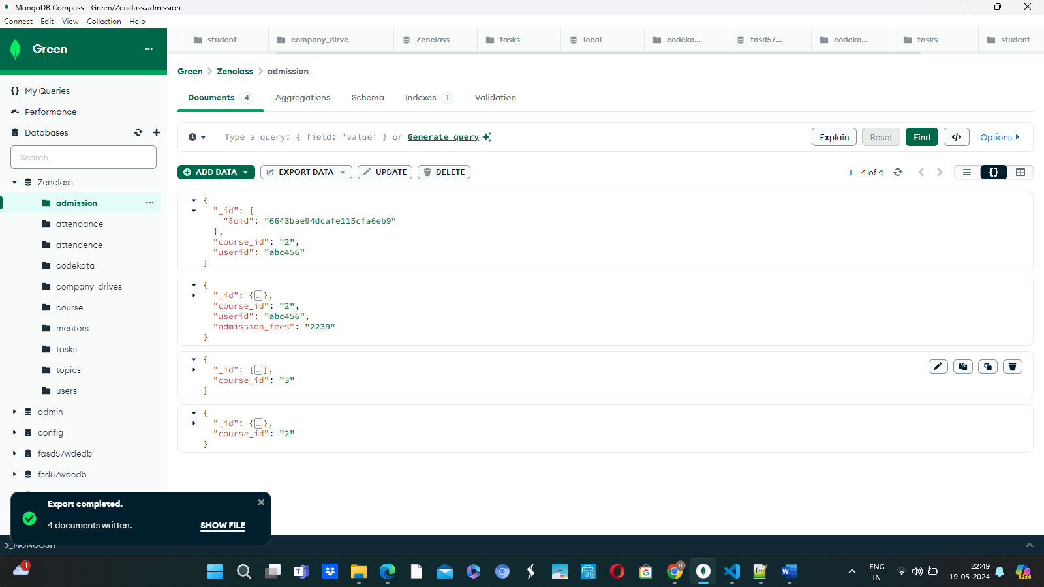

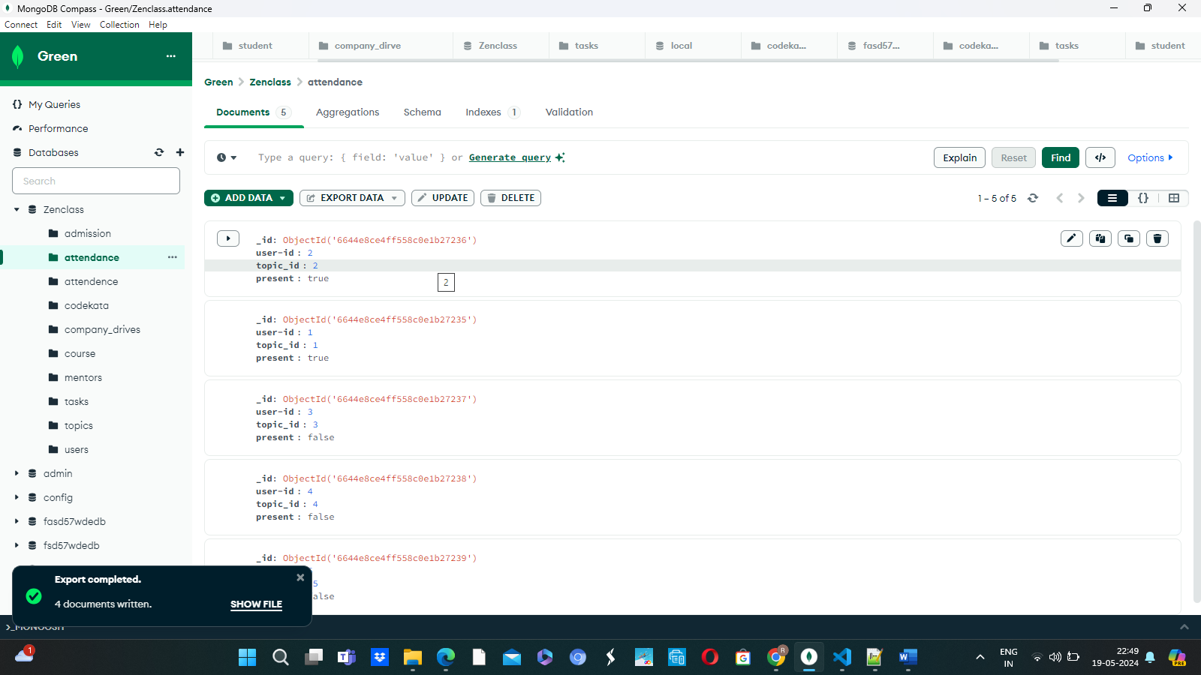

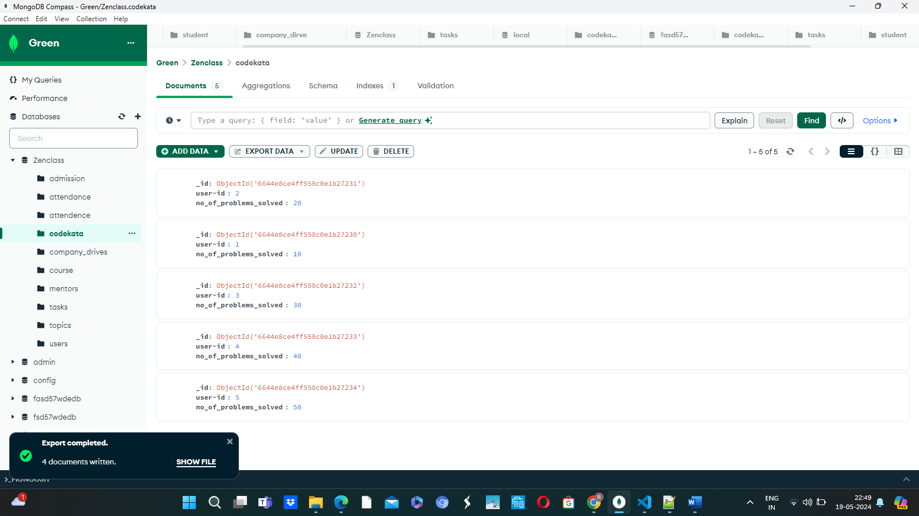

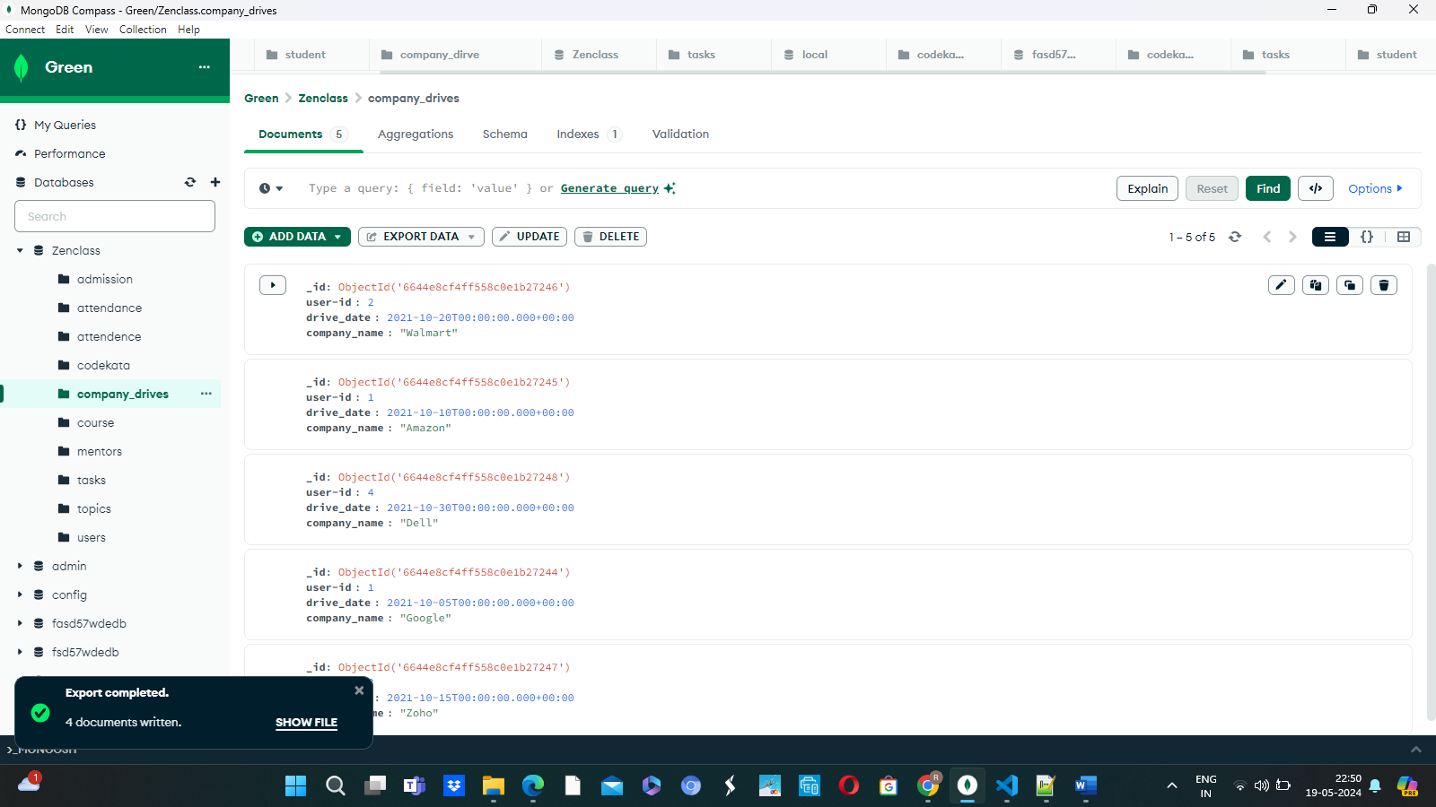

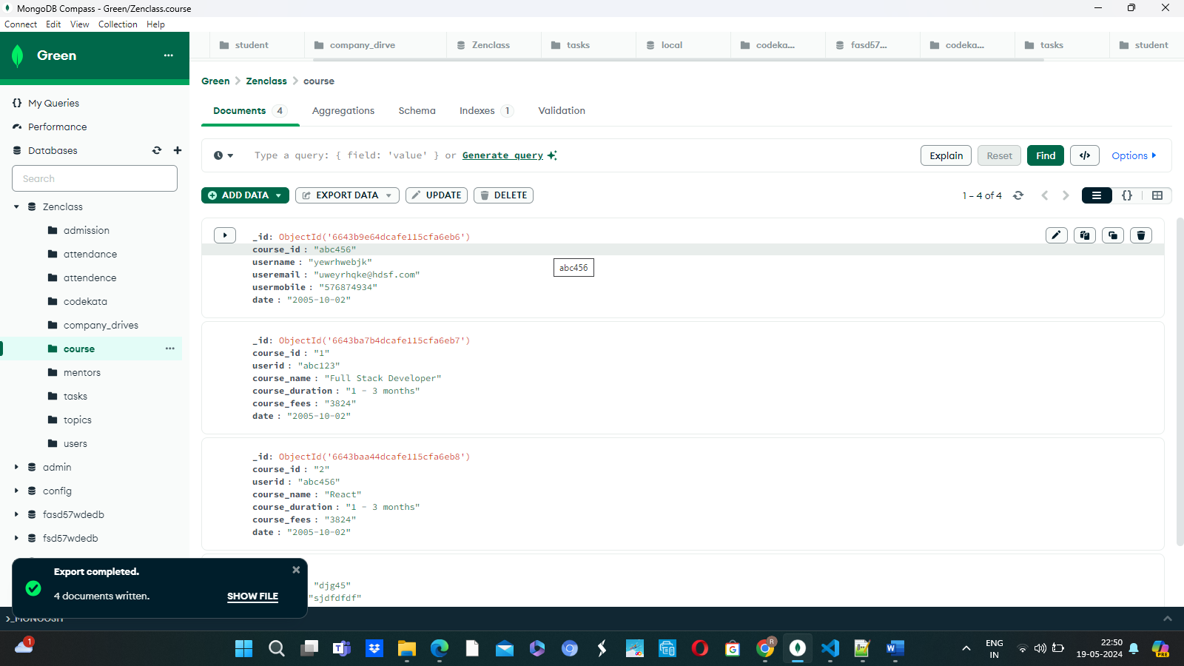

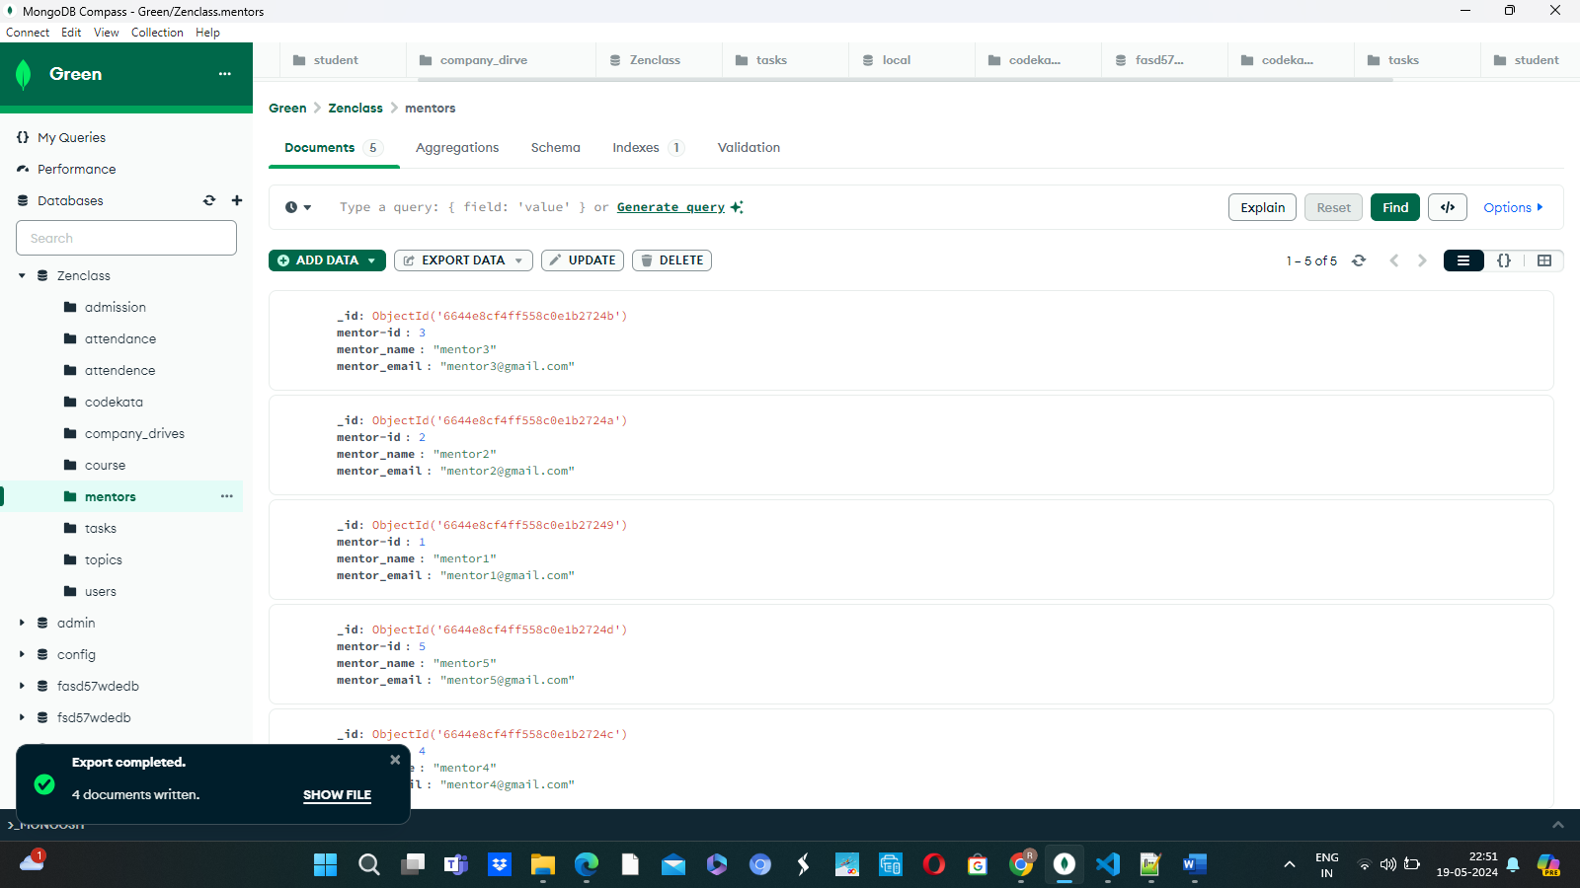

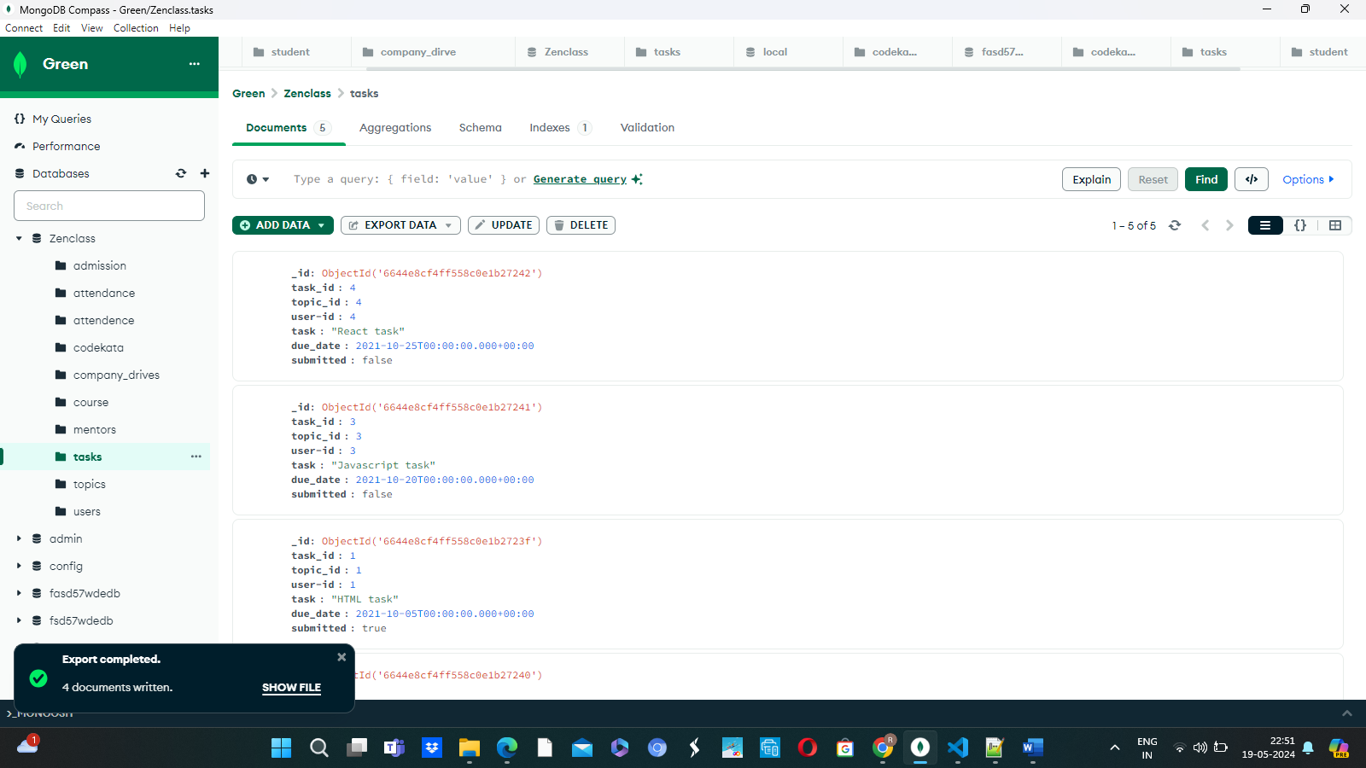

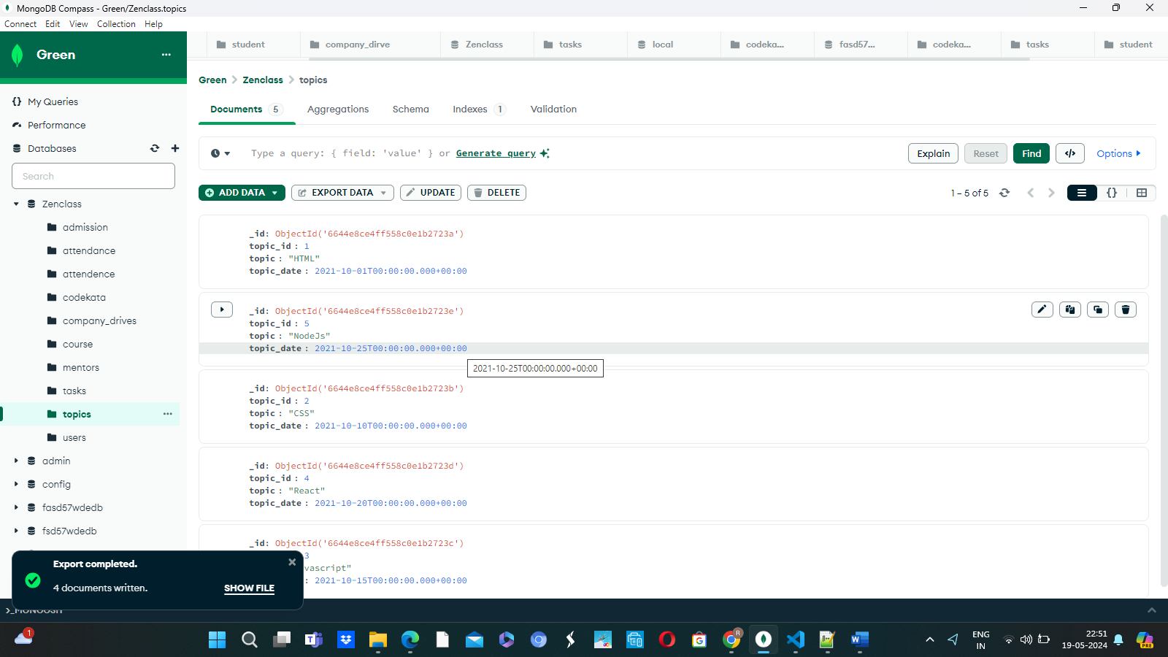

1.db.topics.aggregate([ {$match:{$and :[ { "due":{ $gte:new Date('2021-10-01'),$lte:new Date('2021-10-30')}}]} }]);

2.db.company_drive.aggregate([ {$match:

{

$and :[ {

"date":{

$gte:new Date('2021-10-15'),

$lte:new Date('2021-10-31')

}}]

}}]);

3.db.student.aggregate({$lookup : {from:"company_drive",localField:"_id",foriegnField:"compID",as:"result"}})

4.

db.codekata.aggregate([{$lookup : {from:"student",localfield:"_id",foreignField:"user-id",as:"result"}},{$project :{ "_id":0,"user-id":1,"no_of_problem_solved":1,"result.studentname"}}]);

5. db.mentors.find({mentee_count:{$gte:15}});

5. db.companydrives.aggregate([  
{  
$lookup: {  
from: “users”,  
localField: “userid”,  
foreignField: “userid”,  
as: “info”,  
},  
},  
{  
$project: {  
_id: 0,  
company: 1,  
drive_date: 1,  
“info.name”: 1,  
“info.email”: 1,  
“info.userid”: 1,  
},  
},  
])